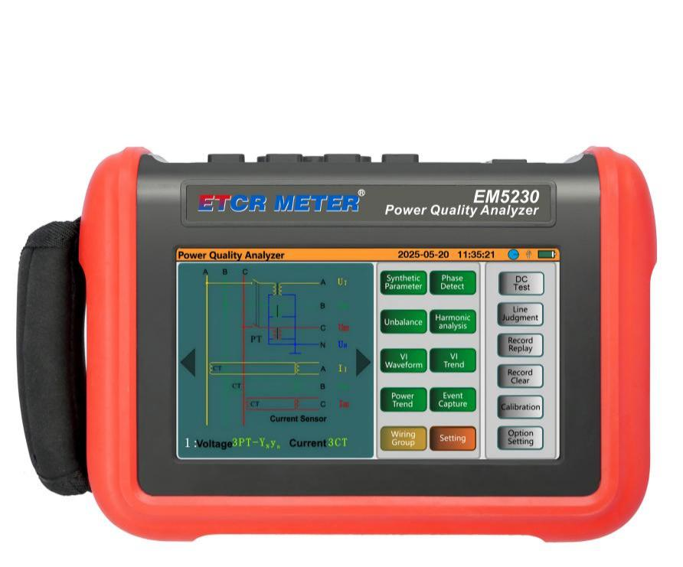
EM5230
Power Quality Analyzer

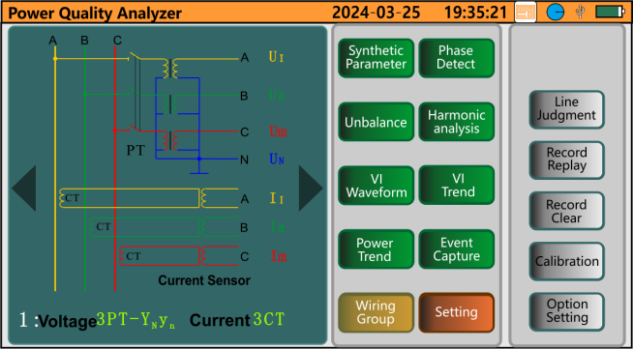
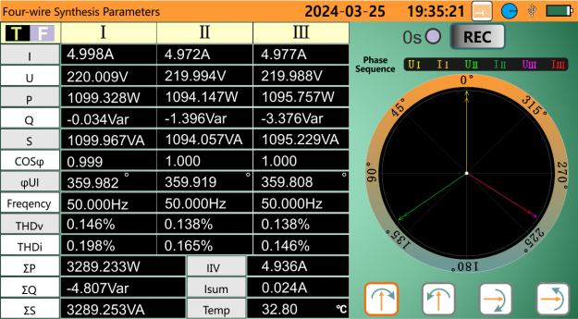
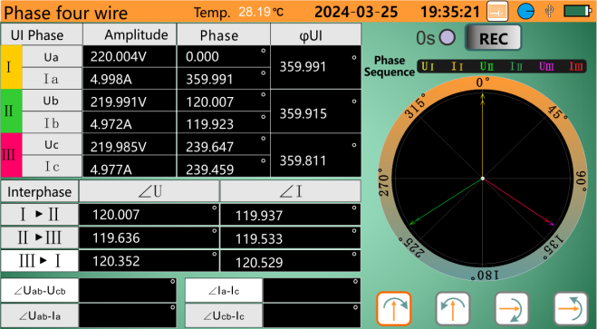
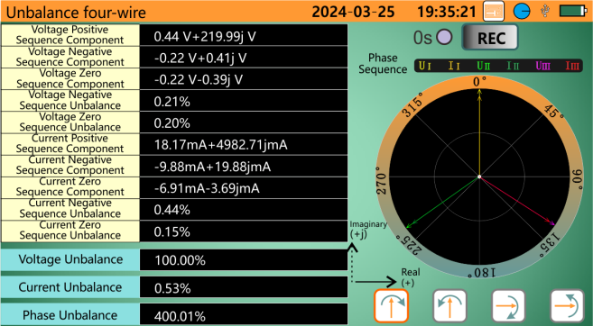
Power on main interface
Comprehensive parameters - 3-phase 4-wire test interface
Phase measurement - 3-phase 4-wire test interface
Unbalance - 3-phase 4-wire test interface

Product Function
- Comprehensive analysis and diagnosis of three-phase power quality.
- 6 types of current sensors for options to application on various sites.
- 4 current and 3 voltage channels are measured simultaneously.
- Testing accuracy is class 0.5, the test is stable and the anti-interference ability is strong.
- Touch colorful screen, simple human-machine operation, and switch with different operation language (Chinese & English).
- USB communication upload the test results to the computer for analysis.
- Equip with large capacity lithium battery.

- Waveform real-time display (3 voltage/4 currents channels).
- True effective values (TRMS) of voltage and current.
- Phase diagram display.
- Each phase harmonics measurement, harmonic up to 51 orders.
- The bar graph shows the harmonic ratio of each phase current and voltage.
- Total harmonic distortion (THD).
- Active/reactive/apparent power value and total value of each phase.
- Voltage & current power trend chart.
- Three-phase unbalance measurement (voltage & current).
- Record waveform and parameters.
- Screenshot and save.
- Touch screen operation.
- Voltage flicker, voltage surge and voltage drop capture.
- Starting current and surge current monitoring.
- USB interface communicate with the computer.
- Setting the wiring connection method and power network type of the instrument.
- Selecting different type clamp current sensor and different voltage test ratio.
- One key to phase volt-ampere testing, turns ratio testing, and DC testing.
- Power energy calculation.
- DC voltage,current and power.
DC

Product Features

Technical Specification

Power Supply | Rechargeable lithium battery 7.4V, 5200mAH, external charger
Display Mode | 7 inch touch colorful screen
Channel | 3 voltage channels, 4 current channels
AC Voltage Range | AC 0.001V ~ 1000V
DC Voltage Range | DC 0.1V ~ 1000V
Clamp Current Sensor (Optional) | 008B Clamp current sensor: Ф8mm;  032B Clamp current sensor: Ф32 x 42mm  050B Clamp current sensor; Ф50mm | 300FA Flexible coil current sensor: Ф300mm  035AD DC current sensor: Ф30 x 35mm  068AD DC current sensor: Ф68mm
Current Range | 008B Clamp current sensor: AC 10mA ~ 10.0A  032B Clamp current sensor: AC 0.1A ~ 100A  050B Clamp current sensor; AC 1A~1000A | 300FA Flexible coil current sensor: AC 10A ~ 6000A  035AD DC current sensor: DC 0.1A ~ 1000A  068AD DC current sensor: DC 0.1A~1000A
Frequency | 40Hz ~ 70Hz
Harmonic | Yes, 2 ~ 51 orders
Total Harmonic Distortion | Yes, 2 ~ 51 orders, each phase
Memory | 8G, expandable to 32G
Three-Phase Unbalance | Yes
Communication Interface | USB
Working Current | Approx. 490mA
Battery Power Indication | Battery symbol display battery power, when the battery power too low, the instrument will automatic shutdown
Automatic Shut Down | When record function enable, the meter will not automatic shutdown
Automatic Shut Down | When record function disable, setting the automatic shutdown time of 15minutes, 30minutes, 60minutes.
Input Impedance | Test voltage input impedance: 1MΩ
Withstand Voltage | The instrument circuit and the housing can withstand 3700V/50Hz sine wave AC voltage for 1 minute.
Insulation | Between the instrument circuit and housing ≥ 10MΩ
Structure | Double insulation, with insulation anti-vibration sheath
Suitable Safety Standard | IEC-61010 CAT III 1000V / CAT IV 600V, IEC-61010-031, IEC-61326, Pollution Degree 2
Working Temperature | - 10℃ ~ 40℃; Below 80%RH
Storage Temperature | - 10℃ ~ 60℃; Below 80%RH
Instrument Weight | Approx. 8kg (include all accessories)
Accessories | Host*1PC;  Instrument tool bag*1PC;  Pen probe test lines*4PCS (each 1PC of yellow, green, red, black);  Alligator clip*4PCS;  Power adaptor*1PC;  4G Memory card*1PC.  Clamp current sensor*(optional)
Instrument Accuracy
Measurement Specification | Range | Display Resolution | Max Error
Frequency | 40Hz ~ 70Hz | 0.001Hz | ± (0.01)Hz
Voltage True RMS | 0.01V ~ 1000V | Min. resolution 0.001V | ± 0.5 % rdg ± 0.1 % fs
DC Voltage | 0.1V ~ 1000V | Min. resolution 0.1V | ± (0.5 % rdg ± 5dgt))
Current True RMS | 0.01mA ~ 6000A | Min. resolution 0.001A | ± (0.5 % rdg ± 5dgt))
DC Current | 0.1A ~ 1000A | Min. resolution 0.1A | ± (0.5 % rdg)
Active Power | 0.001W ~ 6000kW | Min. resolution 0.001W | ± (1 % rdg + 3dgt)；CosΦ ≥ 0.8
Active Power | 0.001W ~ 6000kW | Min. resolution 0.001W | ± (1.5 % rdg + 10dgt)；0.2 ≤ CosΦ < 0.8
Reactive Power | 0.001VAR ~ 6000kVAR | Min. resolution 0.001VAR | ± (1 % + 3dgt); SinΦ ≥ 0.5
Reactive Power | 0.001VAR ~ 6000kVAR | Min. resolution 0.001VAR | ± (1.5 % + 10dgt); 0.2 ≤ SinΦ < 0.5
Apparent Power | 0.001VA ~ 6000kVA | Min. resolution 0.001VA | ± (1 % + 3dgt %)
Power Factor | - 1.000 ~ 1.000 | 0.001 | ± (1.5 % + 3dgt); CosΦ ≥ 0.5
Power Factor | - 1.000 ~ 1.000 | 0.001 | ± (1.5 % + 10dgt); 0.2 ≤ CosΦ < 0.5
Active Energy | 0.001kWh ~ 9999.999MWh | Min. resolution 0.001kWh | ±(1 % rdg + 3dgt)；CosΦ ≥ 0.8
Active Energy | 0.001kWh ~ 9999.999MWh | Min. resolution 0.001kWh | ± (1.5 % rdg + 10dgt)；0.2 ≤ CosΦ < 0.8
Reactive Energy  Inductive & Capacitive | 0.001kVARh ~ 9999.999MVARh | Min. Resolution 0.001kVARh | ± (1 % rdg + 3dgt)；SinΦ ≥ 0.5
Reactive Energy  Inductive & Capacitive | 0.001kVARh ~ 9999.999MVARh | Min. Resolution 0.001kVARh | ± (1.5 % rdg + 10dgt)；0.2 ≤ SinΦ < 0.5
Apparent Energy | 0.001kVAh ~ 9999.999MVAh | Min. Resolution 0.001kVAh | ± (1 % rdg + 3dgt)
Phase Angle | - 179° ~ 180° | 0.001° | ± (3°)
Voltage Harmonic Ratio 2 ~ 51 Orders (Vrms > 50V) | 0.0 % ~ 99.9 % | 0.001% | (2 ~ 20 orders) ± (1 % rdg + 5dgt)  (21 ~ 30 orders) ± (1 % rdg + 10dgt)  (31~51 orders)±(1%rdg+15dgt)
Voltage Harmonic Angle (Vrms > 50V) | -179° ~ 180° | 0.001° | ± (3°) harmonic 2 ~ 25 orders
Voltage Harmonic Angle (Vrms > 50V) | -179° ~ 180° | 0.001° | ± (10°) harmonic 26 ~ 51 orders
Current Harmonic Ratio 2~51 Orders (Arms>I range/100) | 0.0 % ~ 99.9 % | 0.001% | (2 ~ 20 orders) ± (1 % rdg + 5dgt)  (21 ~ 30 orders) ± (1 % rdg + 10dgt)  (31 ~ 51 orders) ± (1 % rdg + 15dgt)
Current Harmonic Angle (Arms >Arms>I range/100) | -179° ~ 180° | 0.001° | ± (3°) harmonic 1 ~ 25 orders  ± (10°) harmonic 26 ~ 50 orders
Total Harmonic Rate  (DF or THD-F) ≤ 50 | 0.0 % ~ 99.9 % | 0.001% | ± (1 % rdg + 10dgt)
Distortion Factor  (DF or THD-R) ≤ 50 | 0.0 % ~ 99.9 % | 0.001% | ± (1 % rdg + 10dgt)
Three-phase Unbalance | 0.0 % ~ 100 % | 0.01% | ± (1 % )
Current Sensor Characteristics (Optional)

Current Sensor Model | Photo | Current True RMS | Max. Resolution | Current True RMS Max Error | Phase Angle φ Max Error
EM008B  CT Size: Ф8mm | 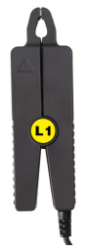 | AC 10mA ~ 10.0A | 1mA | ± (1 % rdg + 0.05 % fs) | ± (2°)
EM032B  CT Size: 35 x 40mm | 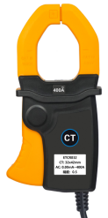 | AC 0.10A ~ 100A | 1mA | ± (1 % rdg + 0.05 % fs) | ± (2°)
EM050B  CT Size: Ф50mm | 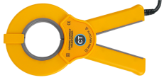 | AC 1.0A ~ 1000A | 1mA | ± (2 % rdg + 0.05 % fs) | ± (2°)
EM300FA  CT Size: Ф300mm | 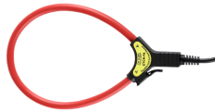 | AC 10.0A ~ 6000A | 1mA | ± (1 % rdg + 0.05 % fs) | ± (2°)
EM035AD  CT Size：Ф30 × 35mm | 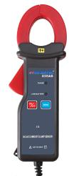 | DC 0.1A - 1000A | 0.1A | ± (3 % rdg + 0.5 % fs)

